// implementation of linked list //

ALGORITHM :

1.create a temporary node(temp) and assign the head node address

2.print the data which present in the temp node

3.after printing the data move the temp pointer to next node

4.do the above process until we reach end

PROGRAM :

#include<stdio.h>

#include<stdlib.h>

Struct node //creating node

{

Int value;

Struct node\*next;

};

//printing the linked list value //

Void printlinkedlist(struct node\*p)

{

While (p!=NULL)

{

Printf(“%d”,p->value);

P=p->next;

}

}

Int main()

{

//initialize nodes

Struct node\*head;

Struct node\*one=NULL;

Struct node\*two=NULL;

Struct node\*three=NULL;

//allocate memory

One=malloc(sizeof(struct node));

Two=malloc(sizeof(struct node));

Three=malloc(sizeof(struct node));

//assign value values;

One->value=1;

Two->value=2;

Three->value=3;

//connect nodes

One->next=two;

Two->next=three;

Three->next=NULL;

//printing node-value

Head =one ;

Printlinkedlist(head);

}

OUT PUT:

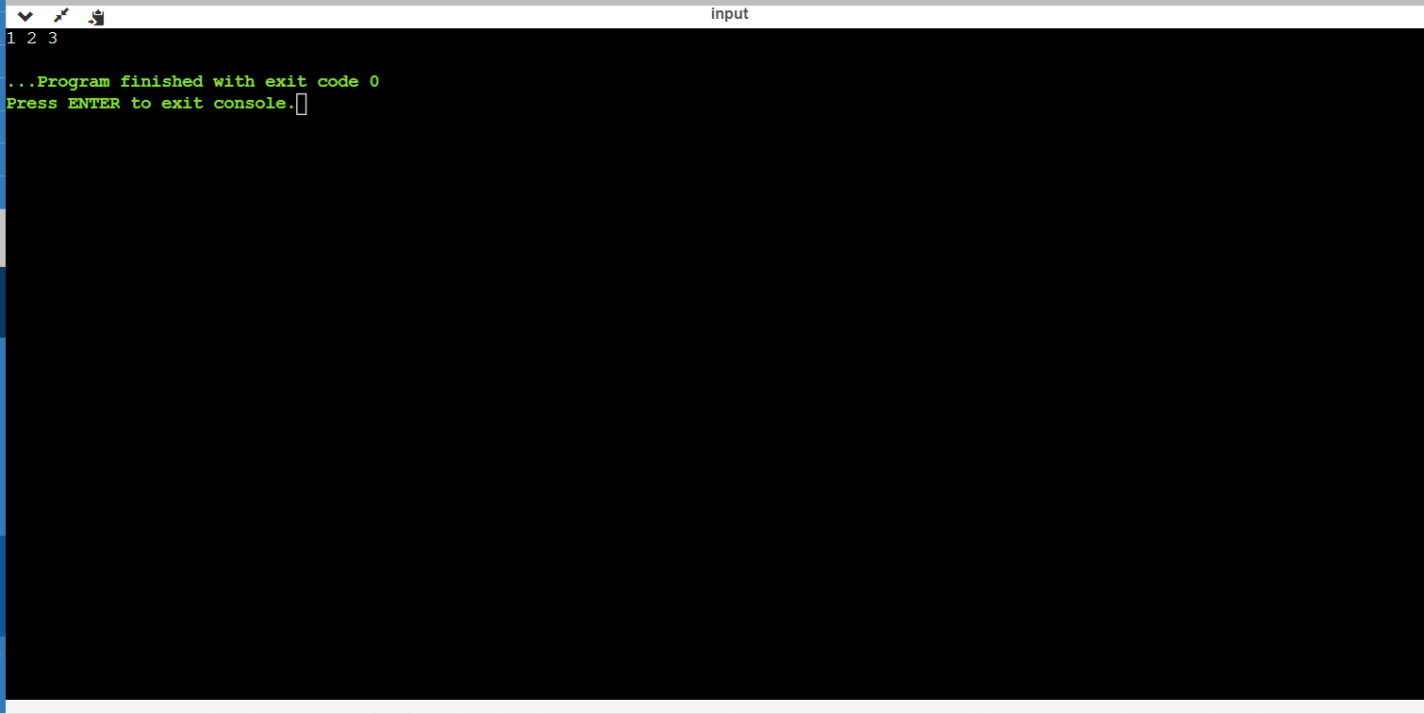

GIT HUB LINK: